Output Capture

Winning Scenario for default mode (Easy):

MAZE GEN default mode (Easy->5\*5)

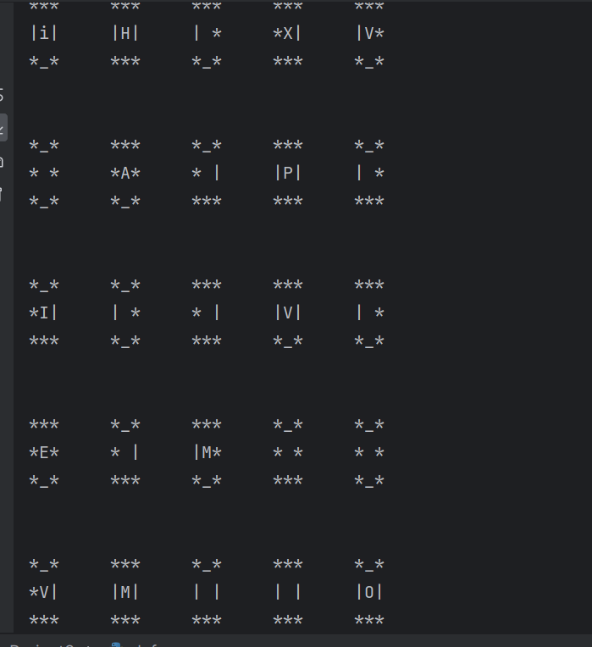

Winning output:

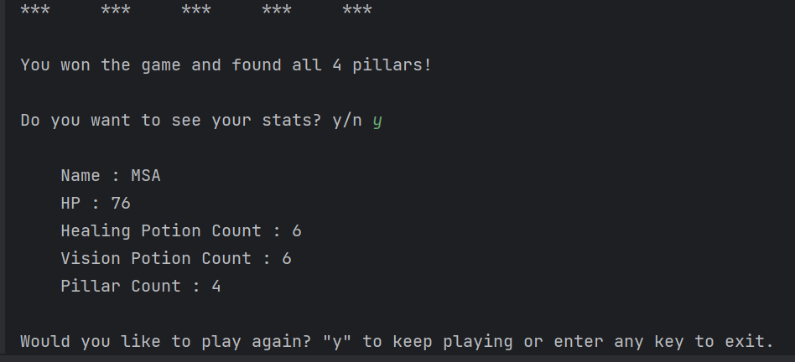

Losing output:

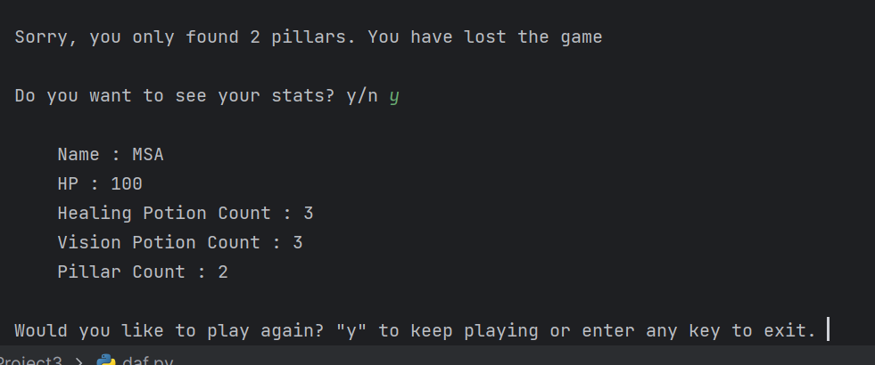

MAZE GEN (medium –> 10\*10):

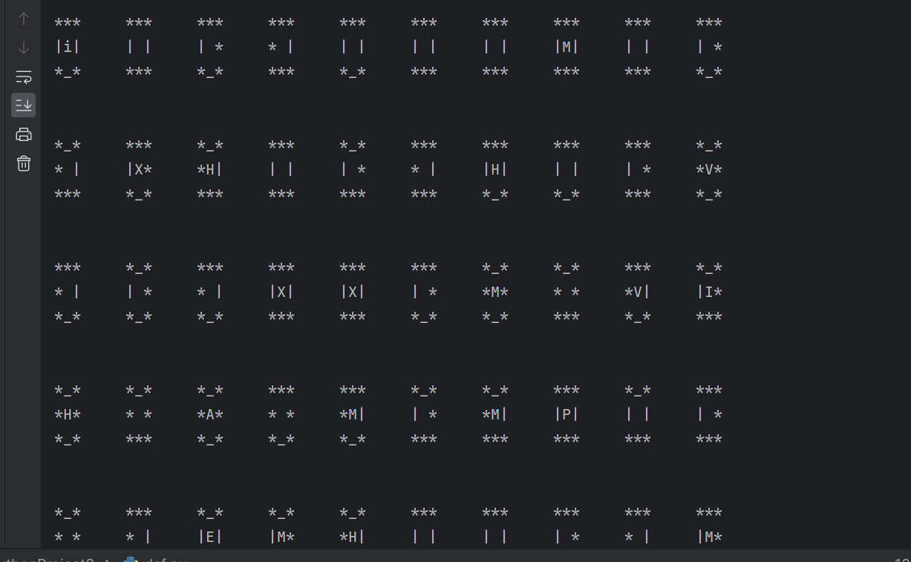

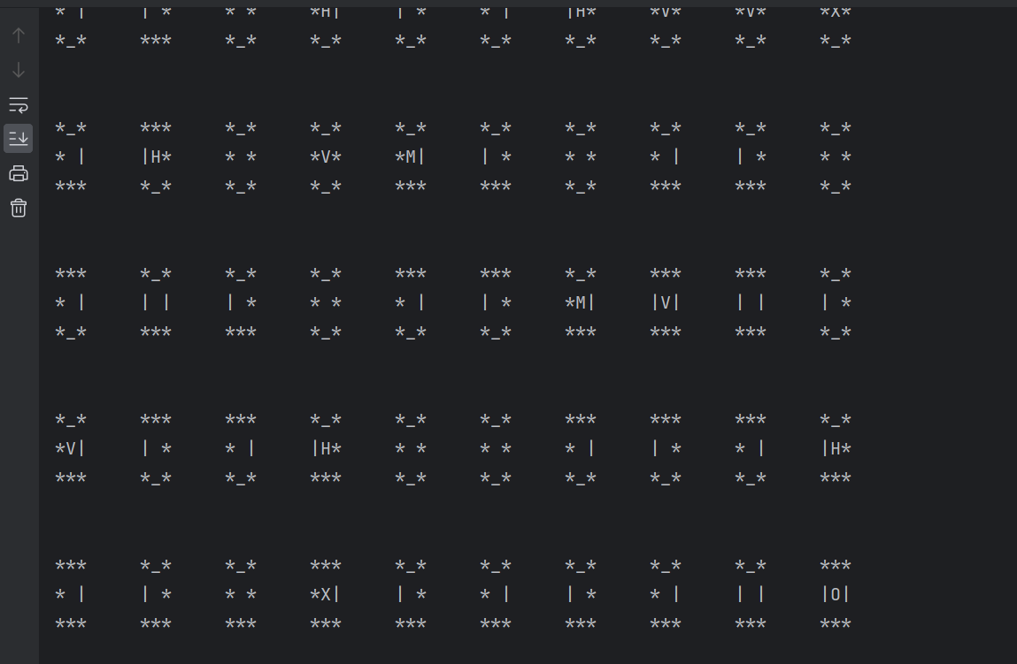

Winning scenario user choice (medium):

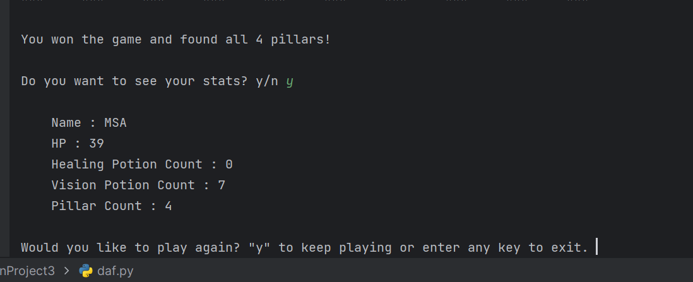

Losing scenario user choice (medium):

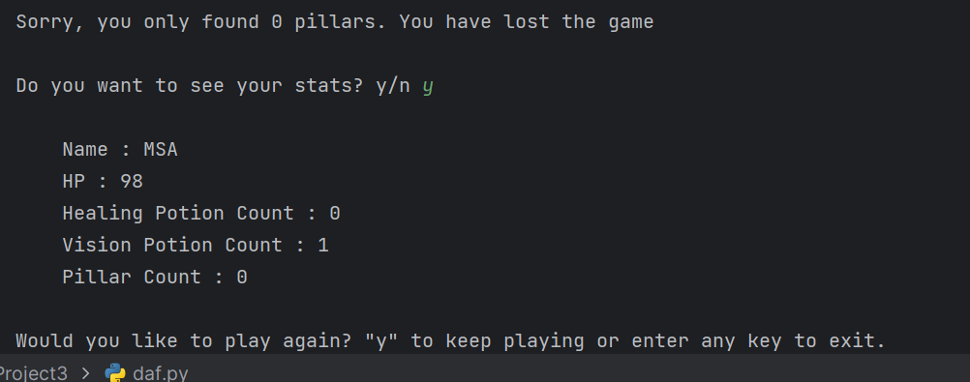

Usage of Vision Potion:

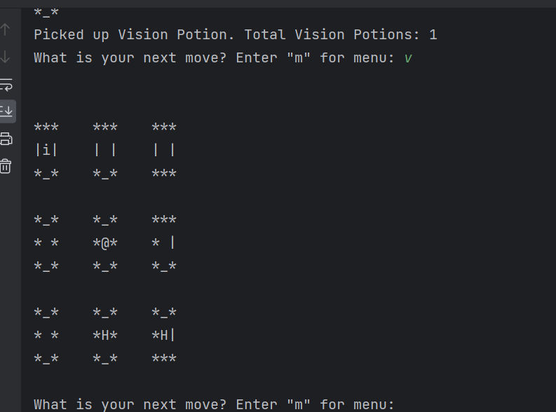

Usage of Healing Potion:

